Restaurant Menu Webpage Project Report

Course: UI/UX Design Fundamentals
Submitted by:
* PRIYAVARSEINEE ANTHIYUR SOMASUNDARAM
ROLL NUMBER : 2462127
priyavarseinee.anthiyur@btech.christuniversity.in

* JINKALA SHAHANAZ
ROLL NUMBER : 2462086
jinkala.shahanaz@btech.christuniversity.in

Submitted to: Dhiraj
Institution: Christ University
Date: [13/08/2025]

1. Abstract

The Restaurant Menu project is a static web application developed using HTML and CSS. The webpage presents a digital menu for a restaurant, categorized into Starters, Main Course, and Desserts. It features responsive design, category filters, and a fixed order button for better usability. The design is mobile-friendly and ensures a visually appealing interface for customers browsing on different devices.

2. Objectives

To create a visually appealing and responsive restaurant menu webpage.

To categorize menu items for better navigation.

To implement clean and semantic HTML structure.

To style the webpage using CSS with hover effects and transitions.

3. Scope of the Project

Focused on front-end design only.

No JavaScript or server-side integration.

Designed for desktop, tablet, and mobile viewports.

Used open-source tools and pure HTML/CSS (no frameworks).

Static content only – no real-time data or ordering system.

4. Tools and Techniques Used

Tool/Technology Purpose

HTML5 Structure of the webpage
CSS3 Styling and layout
Flexbox & Grid Responsive and structured layout
Media Queries Ensuring mobile responsiveness
Unsplash Open-source food images
VS Code Code editor for development
Browser Developer Tools Testing and debugging

5. HTML Structure Overview

Semantic Tags Used: <header>, <section>, <div>

Structure:

1. Header – Restaurant branding and tagline

2. Filters – Category selection

3. Menu Sections – Starters, Main Course, Desserts

4. Fixed Order Button – Persistent for all views

6. CSS Styling Strategy

External CSS file (style.css) for separation of concerns.

Organized with comments for readability.

Techniques used:

Flexbox & Grid for layout

Media Queries for responsiveness

CSS Variables for theme customization

Hover effects and transitions

Mobile-first approach

7. Key Features

Feature Description

Responsive Design Works on desktop, tablet, and mobile devices
Category Filters Allows viewing All, Veg, or Non-Veg dishes
Image Thumbnails Displays each dish with an image
Chef’s Special Badge Animated rotating badge for highlighted dishes
Fixed Order Button Always visible for quick ordering

8.Challenges faced and Solutions
Challenge Solution

Maintaining layout across devices Used Flexbox and Media Queries for responsiveness
Image alignment issues Set fixed height and object-fit for images
Styling radio buttons for filters Used custom CSS with hidden inputs and styled labels

9. Outcome

A clean, responsive, and functional static restaurant menu webpage that meets the design and structure objectives while offering a pleasant user experience.

10. Future Enhancements

Adding JavaScript for functional category filters.

Implementing a working shopping cart.

Adding a backend for real-time menu updates.

Integrating an online ordering and payment system.

11. Sample Code

<!DOCTYPE html>
<html lang="en">
<head>
<meta charset="UTF-8">
<meta name="viewport" content="width=device-width, initial-scale=1.0">
<title>Restaurant Menu</title>
<style>
body {
font-family: Arial, sans-serif;
background-color: #fffdf8;
margin: 0;
padding: 0;
color: #333;
}

header {
text-align: center;
padding: 1.5rem;
background: linear-gradient(to right, #ff7e00, #ffb347);
color: white;
}

h2 {
color: #d35400;
margin-top: 2rem;
border-bottom: 2px solid #f0e0d0;
padding-bottom: 0.3rem;
}

.menu-section {
width: 90%;
max-width: 800px;
margin: auto;
}

.menu-item {
display: flex;
align-items: center;
justify-content: space-between;
padding: 0.8rem 0;
border-bottom: 1px dotted #ccc;
}

.menu-info {
display: flex;
align-items: center;
gap: 1rem;
flex: 1;
}

.menu-info img {
width: 60px;
height: 60px;
object-fit: cover;
border-radius: 8px;
}

.menu-text {
flex: 1;
}

.menu-text h4 {
margin: 0;
color: #333;
}

.price {
color: #27ae60;
font-weight: bold;
min-width: 60px;
text-align: right;
}

/* Filters */
.filters {
display: flex;
justify-content: center;
gap: 2rem;
padding: 1rem;
background-color: #fff4e6;
border-bottom: 2px solid #ffd5b8;
}

.radio-group input {
display: none;
}

.radio-group label {
background-color: #ffe6cc;
padding: 0.4rem 1rem;
border-radius: 15px;
cursor: pointer;
}

.radio-group input:checked + label {
background-color: #ff944d;
color: white;
font-weight: bold;
}

/* Fixed Order Button */
.order-btn {
position: fixed;
bottom: 20px;
right: 20px;
background-color: #ff4e00;
color: white;
padding: 0.8rem 1.2rem;
border: none;
border-radius: 25px;
font-size: 1rem;
cursor: pointer;
display: flex;
align-items: center;
gap: 0.5rem;
box-shadow: 0 4px 8px rgba(0,0,0,0.2);
}

/* Rotating Chef's Badge */
.badge {
display: inline-block;
background-color: #ff4e00;
color: white;
padding: 0.2rem 0.5rem;
font-size: 0.7rem;
border-radius: 50%;
animation: spin 5s linear infinite;
margin-left: 5px;
}

@keyframes spin {
from { transform: rotate(0deg); }
to { transform: rotate(360deg); }
}

</style>
</head>
<body>

<header>
<h1>🍽 Delicious Bites</h1>
<p>Where every bite feels like home</p>
</header>

<!-- Filters -->
<div class="filters">
<div class="radio-group">
<input type="radio" id="all" name="category" checked>
<label for="all">All</label>
<input type="radio" id="veg" name="category">
<label for="veg">Veg</label>
<input type="radio" id="nonveg" name="category">
<label for="nonveg">Non-Veg</label>
</div>
</div>

<div class="menu-section">
<h2>Starters</h2>
<div class="menu-item">
<div class="menu-info">
<img src="https://source.unsplash.com/60x60/?soup" alt="Tomato Soup">
<div class="menu-text">
<h4>Tomato Soup <span class="badge">★</span></h4>
</div>
</div>
<div class="price">₹120</div>
</div>
<div class="menu-item">
<div class="menu-info">
<img src="https://source.unsplash.com/60x60/?bread" alt="Garlic Bread">
<div class="menu-text"><h4>Garlic Bread</h4></div>
</div>
<div class="price">₹80</div>
</div>
<div class="menu-item">
<div class="menu-info">
<img src="https://source.unsplash.com/60x60/?springrolls" alt="Veg Spring Rolls">
<div class="menu-text"><h4>Veg Spring Rolls</h4></div>
</div>
<div class="price">₹150</div>
</div>

<h2>Main Course</h2>
<div class="menu-item">
<div class="menu-info">
<img src="https://source.unsplash.com/60x60/?paneer" alt="Paneer Butter Masala">
<div class="menu-text"><h4>Paneer Butter Masala</h4></div>
</div>
<div class="price">₹250</div>
</div>
<div class="menu-item">
<div class="menu-info">
<img src="https://source.unsplash.com/60x60/?biryani" alt="Chicken Biryani">
<div class="menu-text"><h4>Chicken Biryani</h4></div>
</div>
<div class="price">₹300</div>
</div>
<div class="menu-item">
<div class="menu-info">
<img src="https://source.unsplash.com/60x60/?friedrice" alt="Veg Fried Rice">
<div class="menu-text"><h4>Veg Fried Rice</h4></div>
</div>
<div class="price">₹180</div>
</div>

<h2>Desserts</h2>
<div class="menu-item">
<div class="menu-info">
<img src="https://source.unsplash.com/60x60/?gulabjamun" alt="Gulab Jamun">
<div class="menu-text"><h4>Gulab Jamun</h4></div>
</div>
<div class="price">₹90</div>
</div>
<div class="menu-item">
<div class="menu-info">
<img src="https://source.unsplash.com/60x60/?brownie" alt="Chocolate Brownie">
<div class="menu-text"><h4>Chocolate Brownie</h4></div>
</div>
<div class="price">₹150</div>
</div>
<div class="menu-item">
<div class="menu-info">
<img src="https://source.unsplash.com/60x60/?icecream" alt="Ice Cream Sundae">
<div class="menu-text"><h4>Ice Cream Sundae</h4></div>
</div>
<div class="price">₹120</div>
</div>
</div>

<!-- Fixed Order Button -->
<button class="order-btn" onclick="addToCart()">🛒 Order <span class="cart-counter" id="cartCounter">0</span></button>

</body>
</html>

12. Screenshots of Final Output
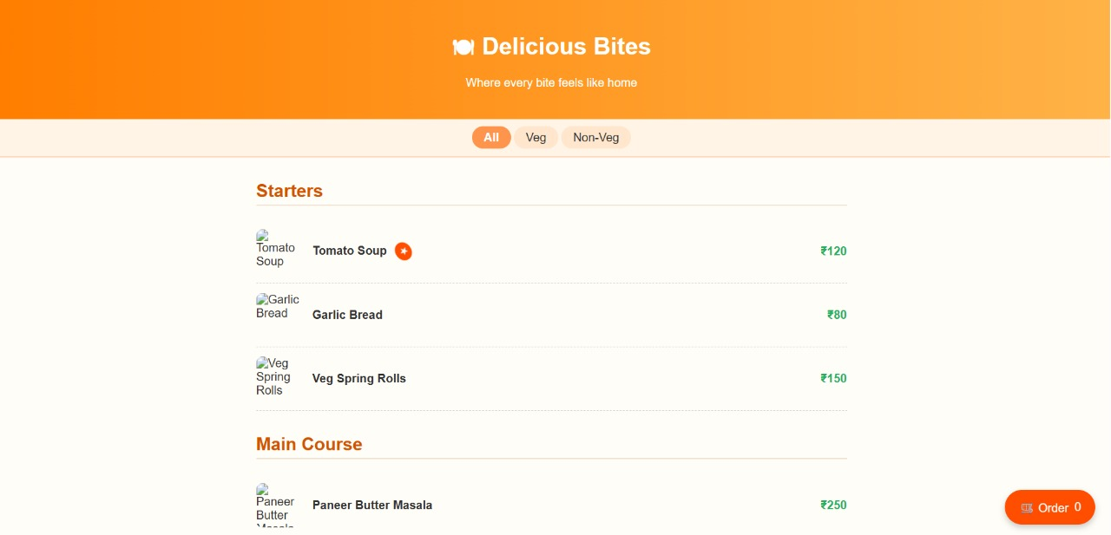
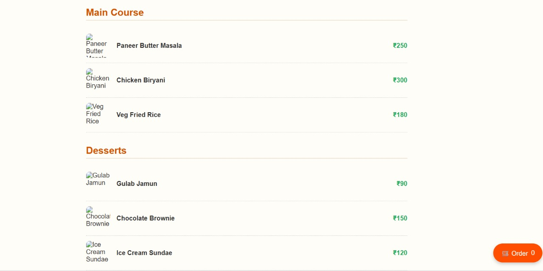

13. Conclusion

The Restaurant Menu project demonstrates effective use of HTML and CSS to design a structured, responsive, and visually appealing webpage. It meets the project scope and objectives, providing a strong foundation for further development into a fully functional online ordering platform.

